**SunRun Specs & Parts List**

**Math**

*Estimated Weight*

* 4” planter weight: ~ 2lbs
* Exterior weight:
  + Octagon with a shortest diameter of 5” has a side length of ~2.7”
  + Octagon area = ~35 square in
  + Assuming height of 4.5”, each octagon slab is ~12 square in in area
  + Total side area = 96 square in
  + Total area = 35 + 96 = 131 square in
  + Assuming ⅜ ” wood thickness, total volume = ~50 cubic in
  + Exterior weight is about 1.5-2 lbs (walnut)
* Total weight = ~3.5/4 lbs

*Estimated Force*

* F = ma
* F(planter) = 1.81 kg * 9.8
* F(planter) = ~17N

*Estimated Torque*

* Assume wheel diameter = 3”; r = 1.5” = 0.04m
* T(system) = F(wheels) * r (radius)
* T(system) = 17 N * 0.04m
* T(system) = ~0.7 Nm
* T(wheel) = ~0.35 Nm

*Estimated Rev*

* Assume max robot speed = human walking speed = ~0.5 m/s
* RPM = v * 2πr * 60 = 0.5 m/s/ 0.08π • 60 = ~120 RPM

*Estimated Power*

* P = w • T
* P = RPM * T / 9.55
* P = 120 * 0.7 / 9.55
* P = ~ 8.8 watts
* P (per motor) = ~4.4 watts

Final Specs

* Target RPM = Up to 120
* Target Wattage = ~ 4.4 watts
* Target torque (per wheel) = .35 Nm

**Functionality**

The robot uses differential drive to spin in place, measuring UV light at intervals in its changing angular position. A gyro sensor associates specific angular positions with UV light intensity. The robot then spins to the direction with the highest intensity, activating its motors (in the same direction) to move forward.

**Parts List**

| Part | Link | Price |
| --- | --- | --- |
| Adafruit LTR390 UV Light Sensor - STEMMA QT / Qwiic | https://www.adafruit.com/product/4831 | $4.95 |
| Triple-Axis Gyro Breakout Board | https://www.adafruit.com/product/1032 | $12.50 |
| USB Battery Pack for Raspberry Pi - 10000mAh - 2 x 5V outputs | https://www.adafruit.com/product/1566#description | $39.95 |
| Adafruit DC & Stepper Motor HAT for Raspberry Pi - Mini Kit | https://www.adafruit.com/product/2348#technical-details | $22.50 |
| Generic High Torque Servo Motor | https://www.sparkfun.com/servo-generic-high-torque-continuous-rotation-standard-size.html | $14.95 **x 2** = $29.90 |
| Continuous Rotation Servo Wheel | https://www.adafruit.com/product/167 | $2.95 **x 2** = $5.90 |
| Supporting Swivel Caster Wheel - 1.3" Diameter | https://www.adafruit.com/product/2942 | $1.95 **x 2** = $3.90 |
| **Total** |  | **$119.60** |

**Circuit Documentation**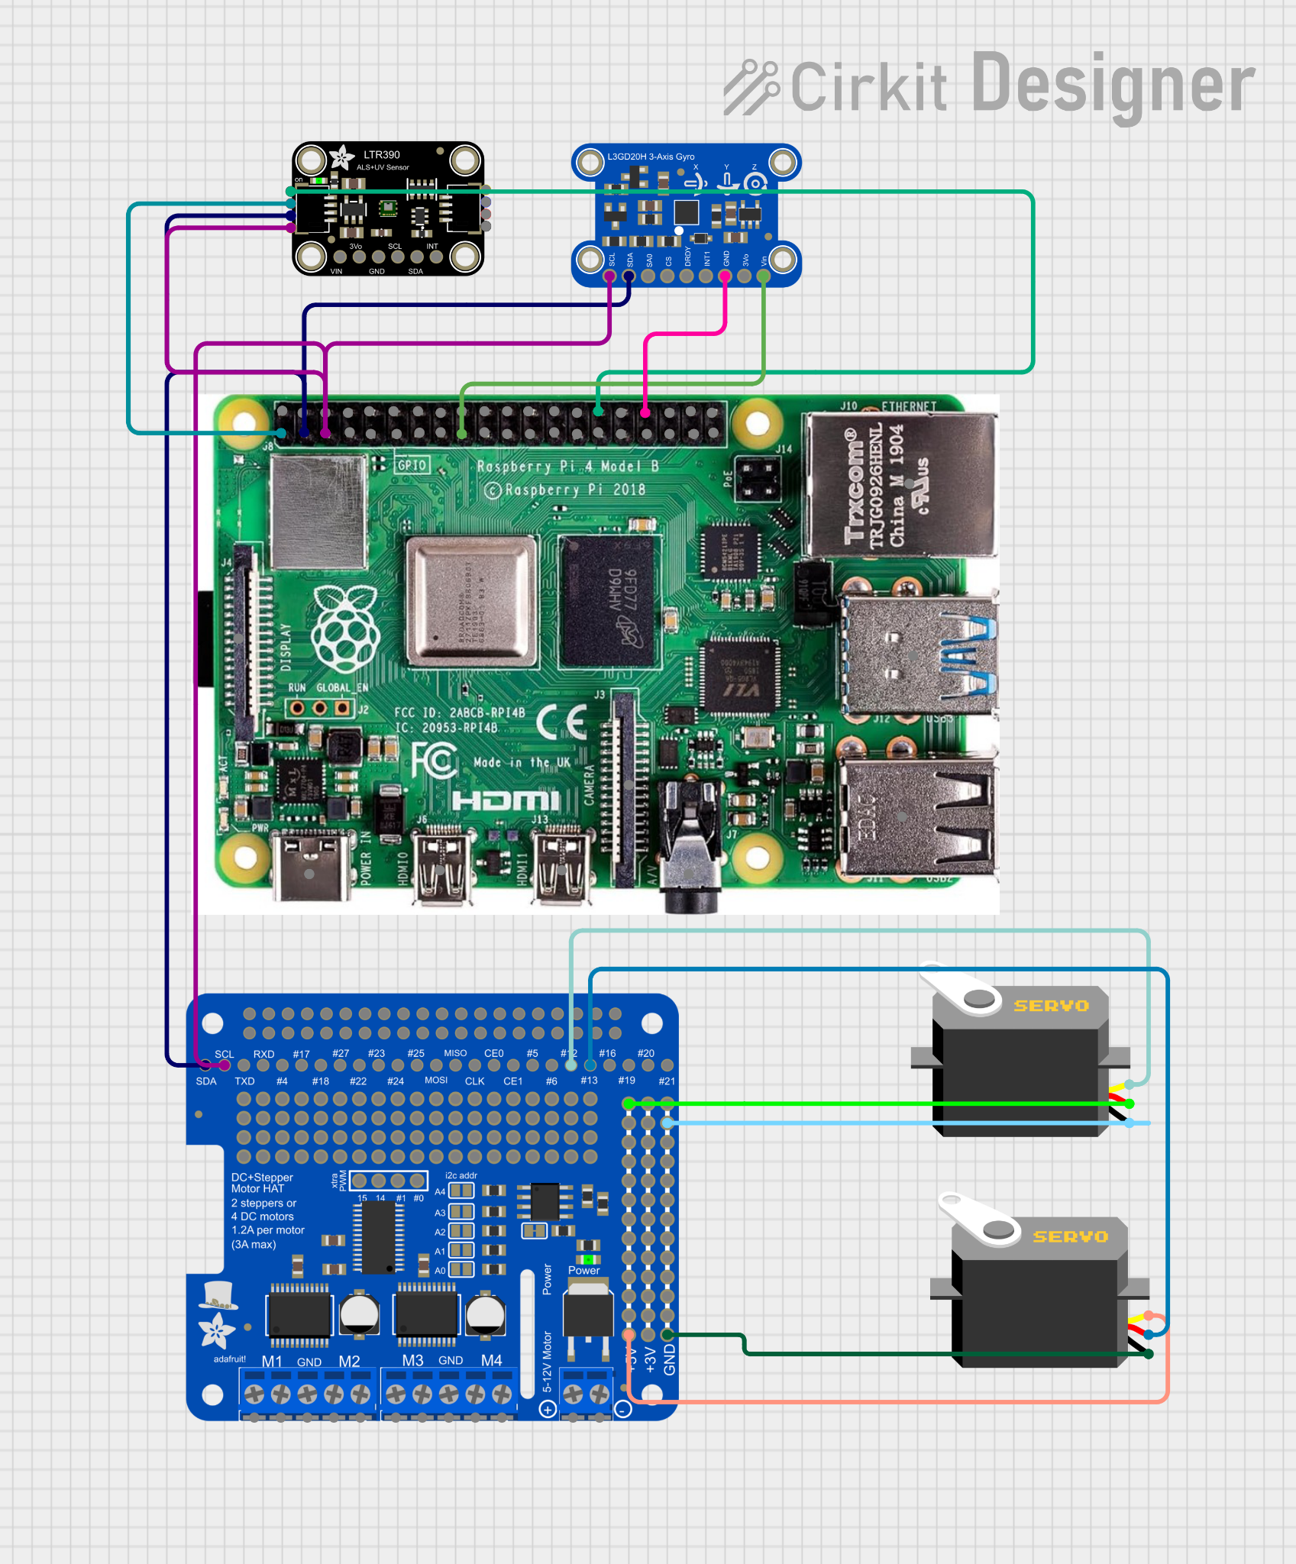

*\* Pi and Hat would be connected to a battery pack with two 5v2A outputs.*